CISCO NSO
End-to-End Acceptance Test Procedure Document
Environment: 172.28.2.17 (CFS) | 172.28.2.18 (RFS) | LSA Deployment (RFS/CFS)
Telangana Fiber Grid Corporation Ltd. (T-FIBER)
Government of Telangana
JULY 07, 2026

Revision History
Revision No. | Date of Submission | Description of Revision | Prepared By | Date of submission for Review | Review completed Date
1.0 | 07th Jul26 | Initial Version - Reformatted to standard ATP template with CLI/UI test case structure | L&T | 07-07-2026

Contents

1 Introduction
This acceptance test report confirms that the Cisco NSO (Network Services Orchestrator) platform has been installed, configured, and verified end-to-end for the T-Fiber network. NSO is the automation system that allows the network team to set up and manage customer internet/fibre connections without manual, device-by-device configuration.
A complete acceptance test was carried out - from confirming the system is running, through submitting a real customer service order, to confirming the physical field device was activated and the order could be safely removed. Every check passed. Test cases are grouped into CLI-based verification (performed directly on the NSO command interface) followed by UI-based verification (performed on the CFS/RFS web dashboards and the Tejas EMS field management application).

Site / Node Details
Environment | 172.28.2.17 (CFS - Customer Facing Service)
RFS Node | 172.28.2.18 (RFS - Resource Facing Service)
Cluster Nodes | RFS-18, RFS-19, RFS-20
Deployment Type | LSA (Layered Service Architecture) - RFS/CFS
Field Management System | Tejas EMS

2 Test Cases

2.1 Test Results Summary
The table below summarizes each verification step performed and its outcome. Full technical evidence (screenshots) for each step is provided in the corresponding test case in Section 2.2 (CLI-based checks) and Section 2.3 (UI-based checks).
# | Checkpoint | What It Confirms | Result
1 | System Health Check | Confirmed the orchestration platform (NSO) is running and available. | PASS
2 | Administrator Access | Confirmed authorized staff can securely log in to the system. | PASS
3 | Network Device Connectivity | Confirmed the platform can reach and communicate with field network devices (OLTs). | PASS
4 | Automation Package Check | Confirmed the provisioning automation package is correctly installed and active. | PASS
5 | Service Order Submission | A real customer service order (fibre connection setup) was submitted for processing. | PASS
6 | Order Processing | The order was processed and committed successfully with no errors. | PASS
7 | Audit Log Verification | System logs correctly recorded the full transaction for traceability. | PASS
8 | Web Portal Verification | The committed order was confirmed visible in both business and network-facing web dashboards. | PASS
9 | Field Device Provisioning | Confirmed the physical field device (OLT) was actually configured to activate service. | PASS
10 | Delete | Confirmed the system can cleanly remove a service order, proving safe rollback capability. | PASS

2.2 CLI-Based Test Cases
These test cases are performed directly on the NSO command-line interface (CLI) and validate the platform, its connectivity, and its provisioning logic before any web-facing verification is attempted.

Test Case 1: System Health Check
Description: | Verify that the NSO orchestration platform is up and running, and confirm the installed software version.
Why This Step: | A system-level health check is performed first because every later step - device connectivity, package status, order processing - depends on the platform being available. Running this check first isolates platform-level issues from service-level issues, so a failure later in the sequence can be attributed correctly.
Procedure: | 1. Login to the NSO server via SSH.  2. Run 'ncs --status' (or enter the NSO CLI with 'ncs_cli' and run 'show ncs-state').  3. Verify the process is reported as running and the installed NSO version is displayed.
Expected Result: | NSO reports a running/up state and returns its installed version with no errors.
Result: | ☐ OK ☐ Not OK
Logs/Snaps:  (if Any) | NSO status check confirming the platform is running.  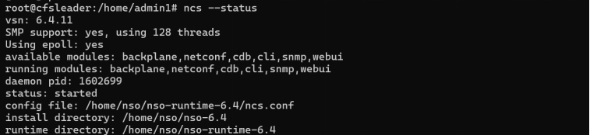

Test Case 2: Administrator Access
Description: | Verify that an authorized administrator can securely log in to the NSO command interface.
Why This Step: | Confirms that access control is functioning as intended - only credentialed staff can reach the platform's command interface - before any configuration activity is attempted. This protects the network from unauthorized or accidental changes.
Procedure: | 1. Connect to the NSO CLI using administrator credentials ('ncs_cli -u admin').  2. Confirm the CLI prompt is reached in operational/configuration mode.
Expected Result: | The administrator logs in successfully and reaches the NSO CLI prompt without error.
Result: | ☐ OK ☐ Not OK
Logs/Snaps:  (if Any) | Administrator logging into the NSO CLI.  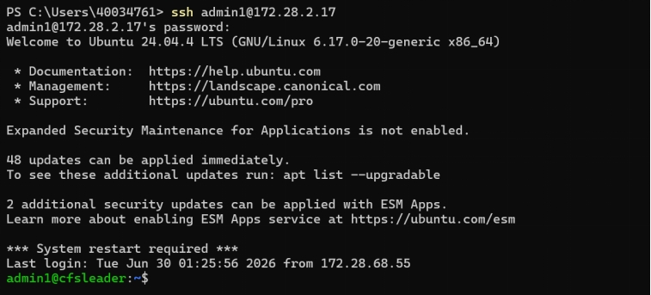

Test Case 3: Network Device Connectivity
Description: | Verify that NSO can reach and communicate with the field network devices (OLTs) it manages, and confirm the RFS/CFS cluster nodes (RFS-18, RFS-19, RFS-20) report the expected role and administrative state.
Why This Step: | NSO can only provision or read from a device once connectivity to it is confirmed. Validating reachability - and confirming the cluster nodes are in the correct Leader/Follower role and Locked/Unlocked state - proves the automation has a working path to the field and a healthy cluster before it is asked to configure anything.
Procedure: | 1. From the NSO CLI, run 'show devices list' and 'show devices device <name> state' to confirm each managed device is reachable.  2. Run the equivalent cluster-status command to confirm the RFS/CFS node roles (Leader/Follower) and administrative state (Locked/Unlocked).
Expected Result: | All managed devices report reachable/connected, and the RFS/CFS cluster nodes report the expected Leader/Follower roles and Locked/Unlocked states.
Result: | ☐ OK ☐ Not OK
Logs/Snaps:  (if Any) | Device connectivity list confirming reachable network devices. (Additional cluster Leader/Follower and Locked/Unlocked state evidence is provided in Annexure A.)  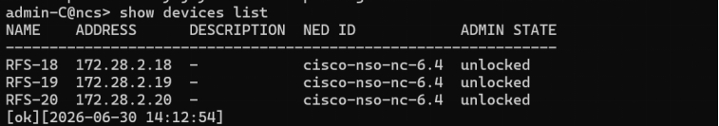

Test Case 4: Automation Package Check
Description: | Verify that the service provisioning automation package is correctly installed and in an operational (active) state on NSO.
Why This Step: | The automation package contains the logic that turns a service order into device configuration. If it is not loaded and active, order submission would either fail outright or silently do nothing, so this check confirms the automation logic itself is ready before it is exercised in the next steps.
Procedure: | 1. From the NSO CLI, run 'show packages package oper-status'.  2. Confirm the relevant service package(s) report an 'up'/enabled state with no load errors.
Expected Result: | The automation package(s) show an active/operational status with no load errors.
Result: | ☐ OK ☐ Not OK
Logs/Snaps:  (if Any) | Service package operational status - confirmed active.  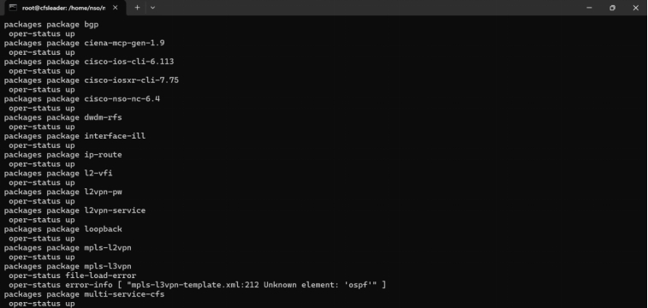

Test Case 5: Service Order Submission
Description: | Submit a real customer service order (fibre connection setup) into NSO, containing the customer and connection details (device, package, VLAN, bandwidth profile, etc.).
Why This Step: | This is the core function under test - it proves that a realistic, end-user service can actually be requested through the automation platform, rather than only proving the platform is idle and healthy.
Procedure: | 1. From the NSO CLI, enter configuration mode ('configure').  2. Create the service instance with the required customer and connection parameters.  3. Run a dry-run/validate before committing to catch any input errors.
Expected Result: | The service instance is accepted with no validation errors and is ready to commit.
Result: | ☐ OK ☐ Not OK
Logs/Snaps:  (if Any) | Evidence captured together with Test Case 6 (Order Processing) below.

Test Case 6: Order Processing
Description: | Commit the submitted service order and confirm it is processed successfully with no errors.
Why This Step: | Submitting an order is not the same as it taking effect. This step proves the transaction actually completes and is pushed down to the network layer, which is the point at which the customer's service genuinely becomes provisionable.
Procedure: | 1. Run 'commit' from the NSO CLI (having reviewed 'commit dry-run' beforehand).  2. Observe the commit result / result summary for errors or warnings.
Expected Result: | The commit completes successfully with no errors or warnings.
Result: | ☐ OK ☐ Not OK
Logs/Snaps:  (if Any) | Confirmation that the order committed successfully.  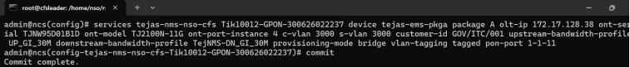

Test Case 7: Audit Log Verification
Description: | Verify that the committed transaction is correctly recorded in the NSO audit log, including the acting user, timestamp, and change details.
Why This Step: | Traceability is a compliance and operational-support requirement - every change made through automation must be attributable to a user and a point in time so issues can be investigated after the fact. This step proves that logging is actually happening, rather than only being assumed.
Procedure: | 1. From the NSO CLI (or the NSO WebUI Audit Log view), query the audit trail for the committed transaction / Service ID.  2. Confirm the entry, acting user, and timestamp are present and accurate.
Expected Result: | The transaction appears correctly and completely in the audit log.
Result: | ☐ OK ☐ Not OK
Logs/Snaps:
(if Any)

2.3 UI-Based Test Cases
These test cases are performed on the web-facing systems - the CFS (172.28.2.17) and RFS (172.28.2.18) web dashboards and the Tejas EMS field management application - and validate that the automated changes made via the CLI are correctly reflected in the systems that business and field teams actually use day to day.

Test Case 8: Web Portal Verification
Description: | Confirm the committed service order is visible in both the business-facing (CFS, 172.28.2.17) and network-facing (RFS, 172.28.2.18) web dashboards.
Why This Step: | Field and back-office teams work primarily through the web dashboards rather than the CLI. This step confirms that what was created via automation is actually visible and searchable to those teams by Service ID, which is what matters for day-to-day operational usability.
Procedure: | 1. Log in to the CFS web portal (172.28.2.17).  2. Search for the committed Service ID and confirm it is present.  3. Log in to the RFS web portal (172.28.2.18) and repeat the search for the same Service ID.
Expected Result: | The committed Service ID is visible and correctly represented on both the CFS and RFS web dashboards.
Result: | ☐ OK ☐ Not OK
Logs/Snaps:  (if Any) | Committed service order confirmed in the CFS (172.28.2.17) and RFS (172.28.2.18) web dashboards by Service ID.  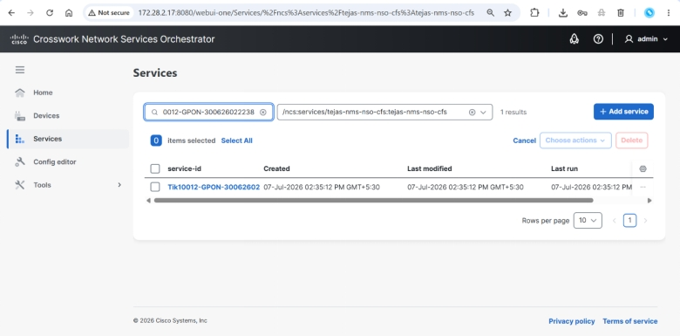  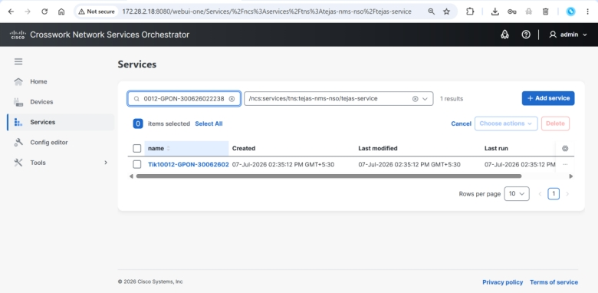

Test Case 9: Field Device Provisioning
Description: | Confirm the physical field device (OLT) was actually configured to activate the service, as seen in the Tejas EMS field management system.
Why This Step: | This is the ultimate proof of end-to-end success - a service order and a committed transaction are only meaningful if they result in the physical OLT actually being configured to deliver the service to the customer.
Procedure: | 1. Log in to the Tejas EMS application.  2. Filter by the relevant ONT Serial Number.  3. Confirm the corresponding OLT service has been provisioned.
Expected Result: | The OLT/ONT service is shown as provisioned/active in Tejas EMS.
Result: | ☐ OK ☐ Not OK
Logs/Snaps:  (if Any) | OLT provisioning confirmed in the Tejas EMS field management system, filtered by ONT Serial Number.  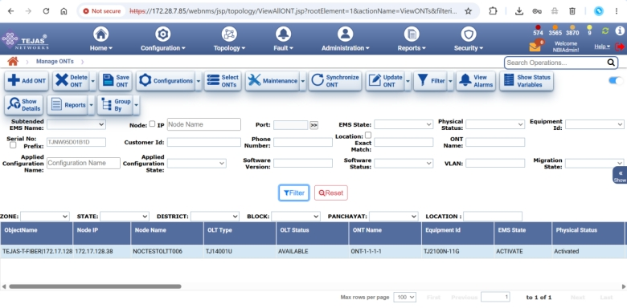

Test Case 10: Delete (Service Order Deletion & Rollback Verification)
Description: | Delete the committed service order and confirm it is cleanly removed from CFS, RFS, and Tejas EMS.
Why This Step: | Being able to safely provision a service is only half the requirement - the platform must also be able to cleanly reverse an order (e.g., for cancellations or correction of errors) without leaving orphaned configuration on the device or inconsistent records between systems. This proves rollback is safe before the platform is trusted for production changes.
Procedure: | 1. In the CFS web portal (172.28.2.17), search for the Service ID, select the service, and perform the delete operation.  2. Verify the Service ID no longer appears in CFS (172.28.2.17).  3. Verify the same Service ID no longer appears in RFS (172.28.2.18).  4. Verify the corresponding service is also removed from Tejas EMS (by ONT Serial Number or relevant service detail).
Expected Result: | The service order is cleanly removed from CFS, RFS, and Tejas EMS with no residual configuration or errors.
Result: | ☐ OK ☐ Not OK
Logs/Snaps:  (if Any) | Delete operation performed in CFS, followed by confirmation of removal from CFS, RFS, and Tejas EMS respectively.  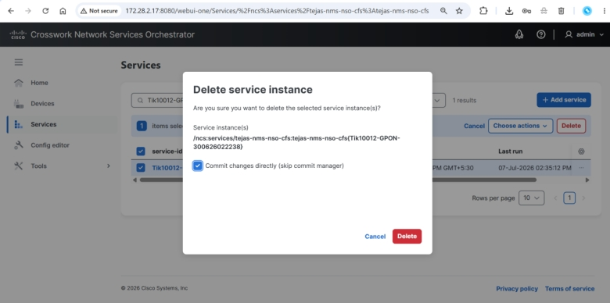  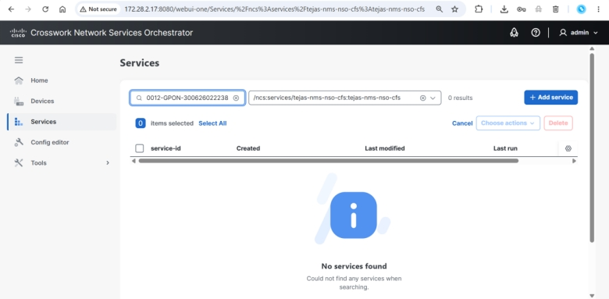  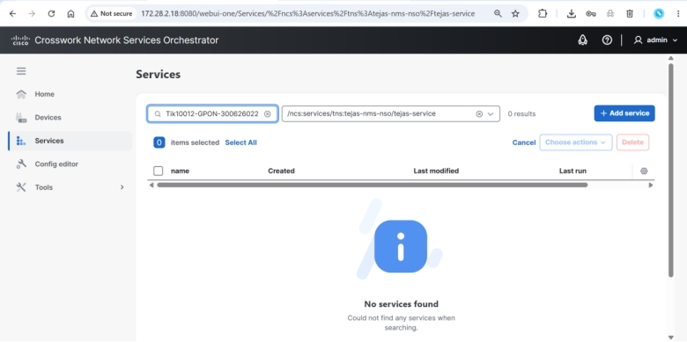  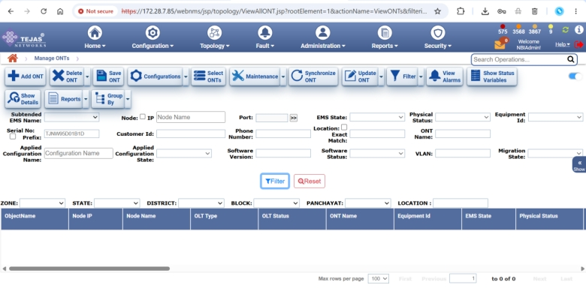

Annexure A: Cluster High-Availability (RFS Leader/Follower & Lock-State) Evidence
This annexure preserves supplementary evidence captured during the acceptance test, demonstrating cluster resiliency behaviour across different RFS node role and administrative-state combinations. It supports Test Case 3 (Network Device Connectivity) and is not a separate numbered test case.

A.1 Baseline Cluster State - RFS-18 Leader, RFS-19 & RFS-20 Followers (All Unlocked)
In the NSO setup, RFS-18, RFS-19, and RFS-20 are configured as RFS nodes, where RFS-18 acts as the Leader and RFS-19 and RFS-20 act as Followers. All RFS nodes (18, 19, and 20) are in the Unlocked state, as shown below.
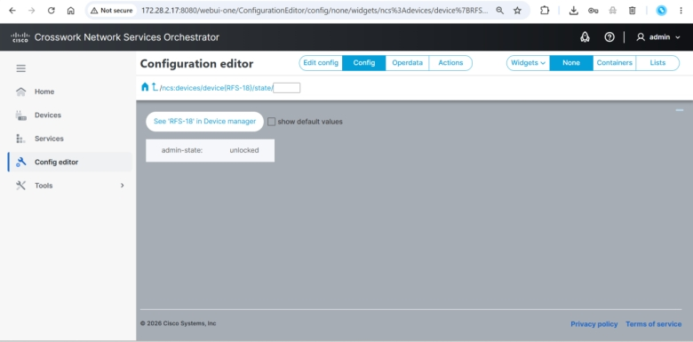
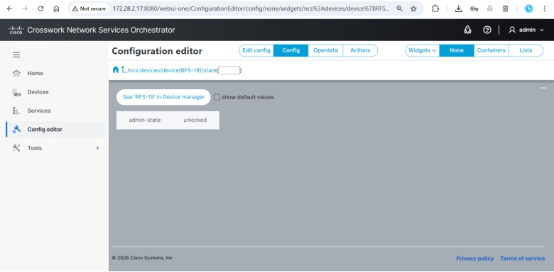
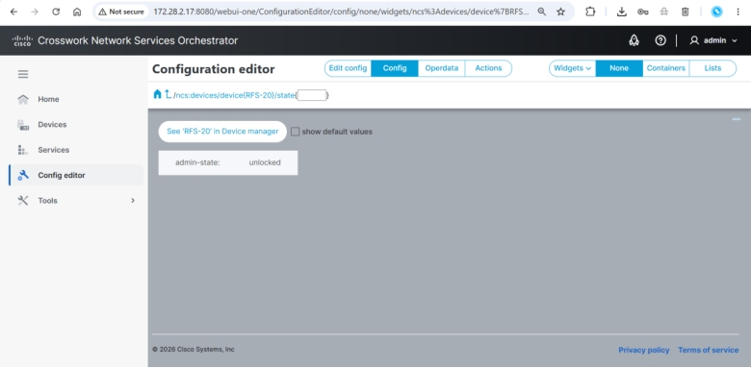
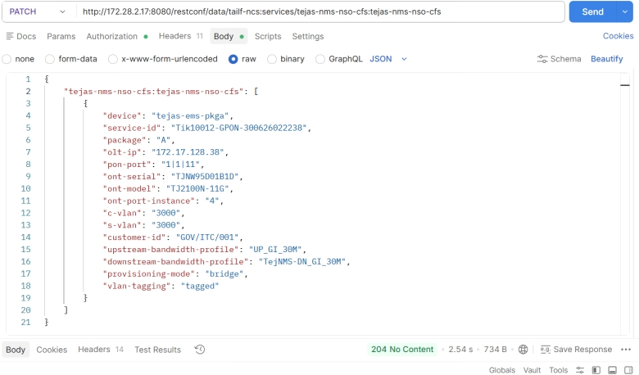

A.2 Scenario - RFS-18 & RFS-20 Locked, RFS-19 Unlocked
RFS-18 and RFS-20 are placed in the Locked state, while RFS-19 remains Unlocked. The committed service order remains correctly visible in CFS, RFS, and Tejas EMS in this state.
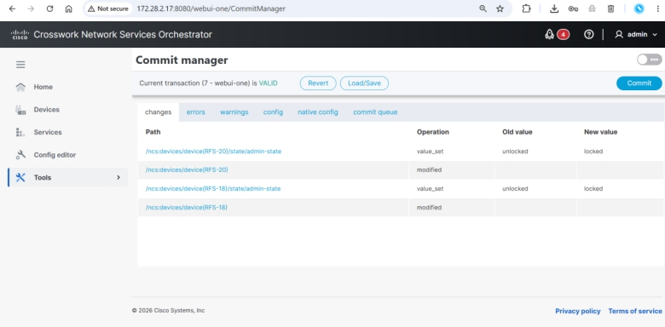
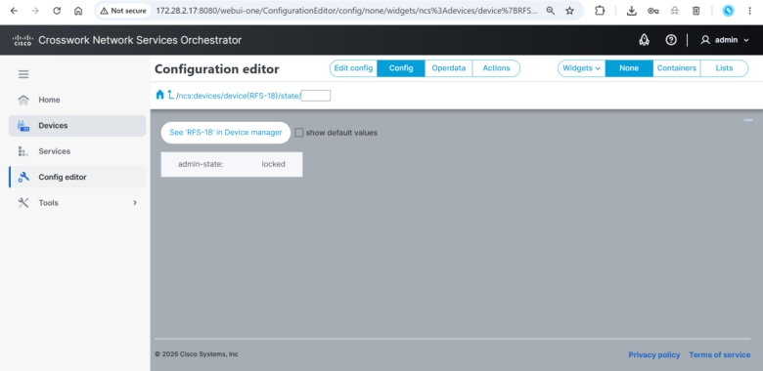
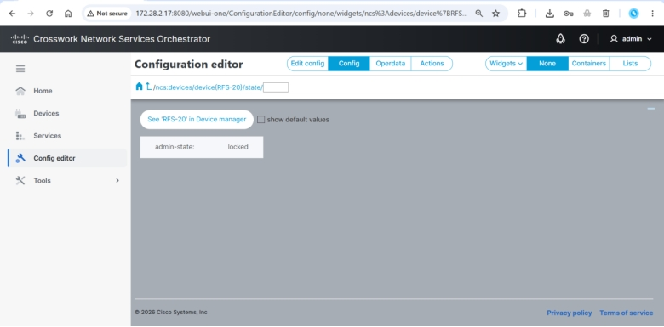
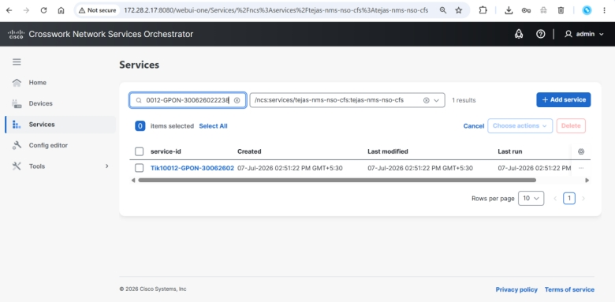
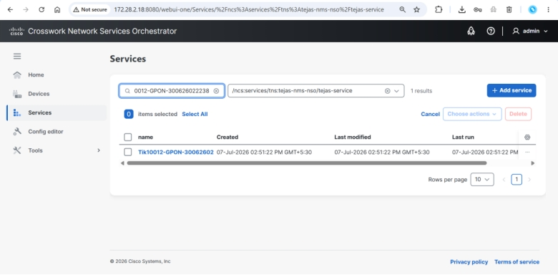
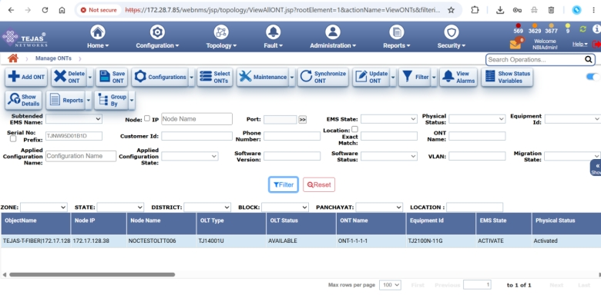

A.3 Scenario - RFS-18 & RFS-19 Locked, RFS-20 Unlocked
RFS-18 and RFS-19 are placed in the Locked state, while RFS-20 remains Unlocked. The committed service order continues to be correctly reflected in CFS, RFS, and Tejas EMS.
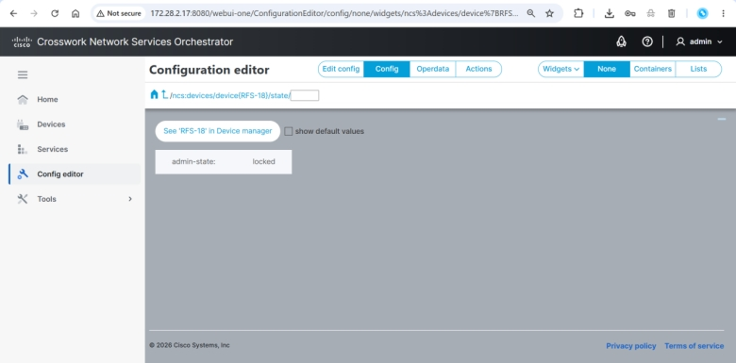
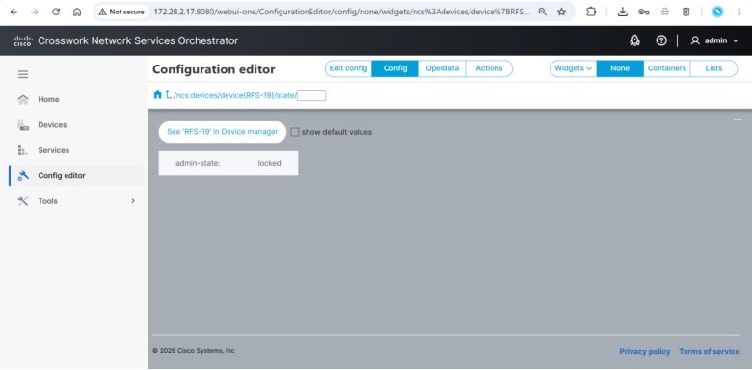
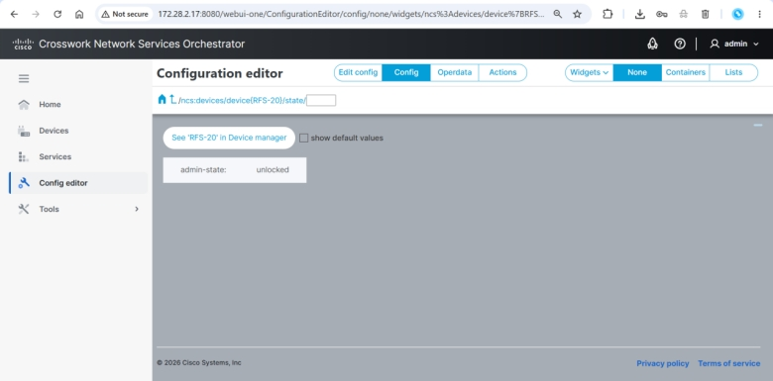
Committed order confirmed in CFS.
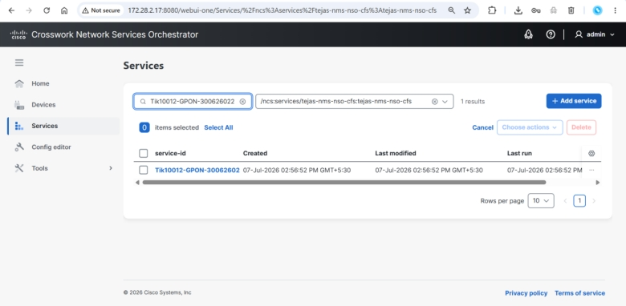
Committed order confirmed in RFS.
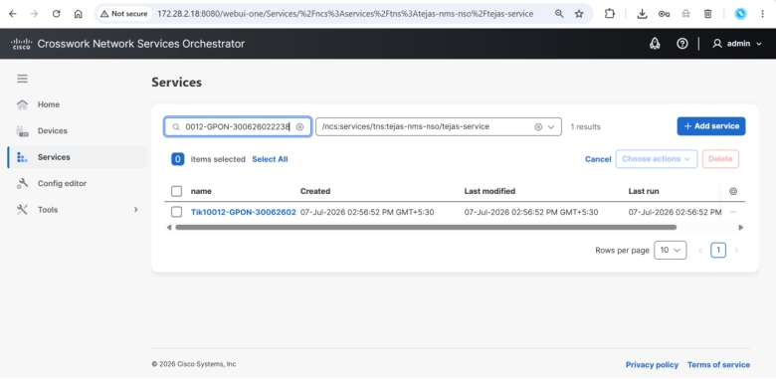
Committed order confirmed in Tejas EMS.
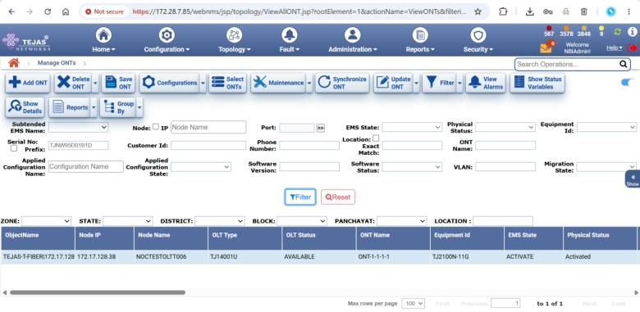

3 Document Acceptance

Organization | MSI Representative | TPA Representative | T-Fiber Representative
Signature
Name
Designation
E-mail ID
Phone Number
Date

